Introduction:

A. This multidisciplinary lab will begin with the creation of gold nanoparticles (Au-NPs) in a chemistry class and will end with an investigation into the antimicrobial proportion of Au-NPs using a cytotoxicity assay.

B. For the past several years, news agencies have been highlighting how nanotechnology is going to change the world. These changes are here and starting to show up in a variety of different places. Filters with nano-sized pores can now filter out almost all bacteria and viruses. Also, there are uses popping up in the medical field from a lab on chip to better deliveries systems for chemotherapy drugs. The clothing industry has even been touched with nano-coated fibers in clothing for stain resistance to event incorporating nanotechnology being incorporated into clothing to make it bullet proof. Nanotechnology is also being used in sunscreen and other cosmetics. The uses of nanotechnology and nanoparticles seem to be growing at an exponential rate. There are great claims of what nanotechnology will do for us in the future. Some of these claims are too big to believe. There is talk of self-healing plastics being put in electronics so that when you drop them they heal themselves. There is also a claim that with carbon nanotubes we could build a space elevator.

One such area that been looked at by nanotechnology and the medical field is using nanotechnology as an antimicrobial. Bacterial infections continue to be a serious threat to human health and the rise of antibiotic-resistant microbes has made the situation even more dire. The lack of newly approved antibiotics has also contributed to this unfortunate situation, and thus, there is an increasing need for the deployment of new instruments with antibacterial properties. Gold nanoparticles may have some ability to fight bacteria.

The purpose of this activity is to look at this possibility. Citrate coated gold nanoparticles will be created. These nanoparticles will then be applied to a colony of E. coli bacteria to gauge the cytotoxicity of gold nanoparticles in different concentrations.

C. When done you should be able to:
1. Compare sizes of nano-sized object to other small objects including living things.
2. Identify how nanotechnology is being used to tackle some problems in engineering and medicine.
3. Analyze results of the activity and relate the results to how it could potentially harm an ecosystem.
4. Draw conclusions about the best way to mitigate the impact of nanoparticles on the environment.
5. Be able to recommend the best concentrations of Au-NPs in medicine for antimicrobial uses.

Pre-Lab (Both Sections)

A. Listen to the in-class presentation on the nanoscale.
B. Watch this video on scale: https://youtu.be/uaGEjrADGPA

1. At what scale is bacteria present and how much smaller is the nanoscale?
______________________________________________________________________________
______________________________________________________________________________
______________________________________________________________________________
C. Go to this link see what the National Nanotechnology Initiative thinks will be able to be done with nanotechnology: https://www.nano.gov/you/nanotechnology-benefits

2. What are the six areas listed that have the greatest potential to use nanotechnology?
______________________________ ______________________________
______________________________ ______________________________
______________________________ ______________________________

3. What is the difference between nano-engineered and using nanoparticles?
______________________________________________________________________________
______________________________________________________________________________
______________________________________________________________________________
______________________________________________________________________________
______________________________________________________________________________

4. Why do you think nanotechnology seems to have so many different applications?
______________________________________________________________________________
______________________________________________________________________________
______________________________________________________________________________
______________________________________________________________________________

Lab Part 1 (Chemistry): Synthesis of Gold Nanoparticles: (Adapted from the work of David Bergandine, Tom Gelsthorpe, Terry Koker, Joe Muskin, and Matt Ragusa¹)

Materials:
Ruby-Red Colloidal Gold - Kit  1 mM HAuCl₄  1% Trisodium Citrate solution  1 250 mL beaker  1 piece of 2” Parafilm | 1 Test Tube rack  2 Sterile Graduated pipettes  1 small test tube  1 hot plate  Deionized water

Procedure:
- Obtain a 250 mL beaker and fill it with approximately 125 mL of water.
- Place the beaker on a hot plate.
- Boil the water
- While the water warms obtain a test tube and wash it with soap and water and then rinse several times with distilled or deionized water (if possible use milli-Q water)
- Obtain 1 mL of 1 mM HAuCl₄ using sterile disposable pipet and place it in test tube (use the graduations on the pipet for measuring)
- Use another pipet to obtain 1 mL of distilled or deionized water and place it in the test tube.
- Place the test tube in the now boiling water and let heat for approximately 10 minutes to heat up the solution.
- After 10 minutes obtain a pipet with some warmed 1% trisodium citrate solution and place 5 drops of the solution in the test tube with the 1 mM HAuCl₄ and distilled water.
- Continue heating the test tube for ~5 minutes. (Watch for a color change that should start with blue then turn to light purple and eventually ruby red)
- Once the test tube contents have turned ruby read remove from the bath and place in a test tube rack for cooling.
Once cool, Parafilm the test tube until needed for the cytotoxicity assay.

Post Lab Questions for Synthesis of Gold Nanoparticles:

1. What problems with making gold nanoparticles did you find when doing the procedure? How would you fix any issues?
__________________________________________________________________________________________________________________________________________________________________________________________________________________
__________________________________________________________________________________________________________________________________________________________________________________________________________________
________________________________________________________________________________________________________________________________________________________________________________________________________________________________________________________________________________________________________________________________________________________________________________________________________________________________________________________________________________________________________________________________________________________________________________________________________________________________________________________________________________________________________________________________________________________________________________________________________________________________________________________________________

2. How easy was it making gold nanoparticles? What could you use to figure out if the size of the particles was correct?

__________________________________________________________________________________________________________________________________________________________________________________________________________________
__________________________________________________________________________________________________________________________________________________________________________________________________________________
___________________________________________________________________________________________________________________________________________________________________________________________________________________________________________________________________________________________________________________________

3. Group Project: (15 min for two days) On a separate piece of paper design a method to calculate the number of mg/L of Au-NPs that were produced. Be specific; giving the materials needed and a detailed procedure. Be ready to explain your groups ideas to the rest of the class.

Lab Part 2 (Biology) Cytotoxicity Assay:
Materials:

E. coli culture (order 1 week beforehand) 2 Agar plates (sterile)
50 ml centrifuge tube (sterile) 2 disposable pipettes (sterile)
LB Broth (sterile) 1000 ml Pyrex bottle filled with sterile water
10 1000 ul pipette tips or straws (sterile) Colloidal gold nanoparticles (made in the synthesis lab)
9 1.5 ml centrifuge tubes (sterile) Preferred, but optional: Cell incubator
70% isopropyl alcohol

Procedure:
Drawings are referenced in the directions.

- Watch this method being demonstrated in the link or search for keywords: Ouchterlony Assay
  - https://www.youtube.com/watch?v=Fnx5CkGRBEM
- Fill a sterile 50 ml centrifuge tube with approximately 45 ml of LB broth.
- Transfer 1 ml of the E. coli suspension into the 45 ml container. Fig. A
- Place the E. coli suspension in a 37º C incubator.
  - Remove when the culture has reached ≈ 10⁸ CFU or is cloudy. (≈ 24 hours in the incubator)
- Inoculate the two LB agar plates using a sterile disposable pipette with 2 drops or 100 ul of the E. coli culture. Fig. B
- Slowly rotate each plate while moving the hockey stick across the surface of the agar plate. Fig. C
- Stop as soon as the liquid is evenly distributed across the plate. Replace the lid.
- After the liquid has been absorbed (5 min), bore five wells with a sterile, trimmed 1000 ul pipette tip, disposable pipette or similarly sized straw in the pattern of the five dots on a die face in each plate. Fig. D
- Prepare sample and control dilutions to place in the wells using the sterile 1.5 ml centrifuge tubes.
  - Tube 1a: 1 ml sterile water (sH₂O)-----------------------> Will be placed in well 1a
  - Tube 2a: 1ml 70% isopropyl alcohol (IPA)-------------> Will be placed in well 2a
  - Tube 3a: 0.25 ml sH₂O, 0.75 ML IPA----------------------> Will be placed in well 3a
  - Tube 4a: 0.5 ml sH₂O, 0.5 ML IPA-------------------------> Will be placed in well 4a
  - Tube 5a: 0.75 ml sH₂O, 0.25 ML IPA----------------------> Will be placed in well 5a
  - Tube 1b: 1 ml sterile water (sH₂O) -----------------------> Will be placed in well 1b
  - Tube 2b: 1 ml of gold nanoparticles (Au-NPs) ---------> Will be placed in well 2b
  - Tube 3b: 0.25 ml sH₂O, 0.75 ML Au-NPs-----------------> Will be placed in well 3b
  - Tube 4b: 0.5 ml sH₂O, 0.5 ML Au-NPs--------------------> Will be placed in well 4b
  - Tube 5b: 0.75 ml sH₂O, 0.25 ML Au-NPs-----------------> Will be placed in well 5b
- Plate A (IPA Plate):
  - Label each well on the bottom of the plate: 1a, 2a, 3a, 4a, and 5a.
  - Place 2 drops (100 ul) of the sH₂O or IPA into the aforementioned wells. Fig. E
    - Example: place 2 drops from tube 1a into well 1a on plate. Replace lid.
  - After the liquid has been slightly absorbed (5 min), place the plate right-side up in the incubator.
- Plate B (Au-NPs Plate):
  - Label each well on the bottom of the plate: 1b, 2b, 3b, 4b, and 5b.
  - Place 2 drops (100 ul) of the sH₂O or Au-NPs into the aforementioned wells. Fig. E
    - Example: place 2 drops from tube 1b into well 1b on plate. Replace lid.
  - After the liquid has been slightly absorbed (5 min), place the plate right-side up in the incubator.
- Incubate the plates in the incubator for ≈ 24 hours at 37º C. Fig. F
- Remove plates and measure the zone of inhibition. This is the area the E. coli did grow due to the cytotoxic effects of IPA and/or Au-NPs.
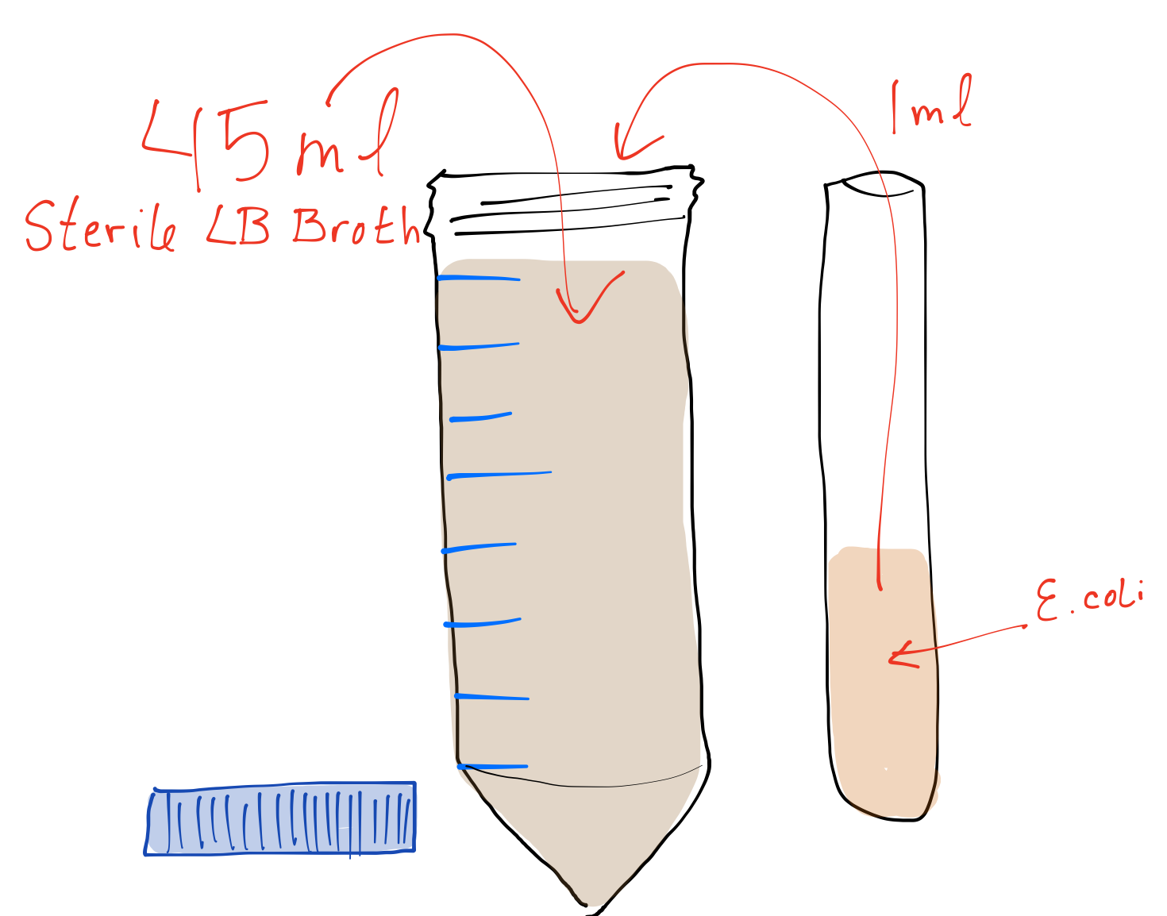
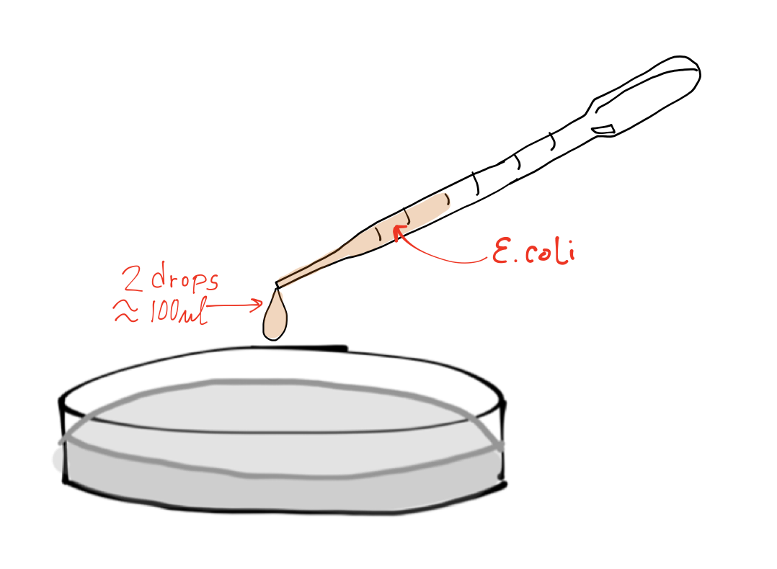
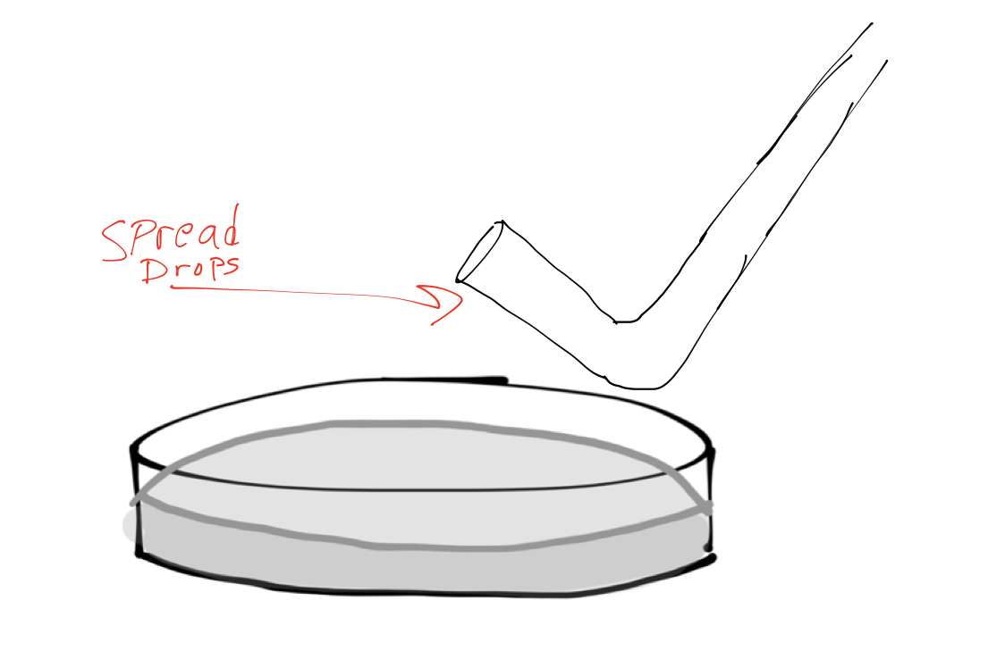
C
B
A

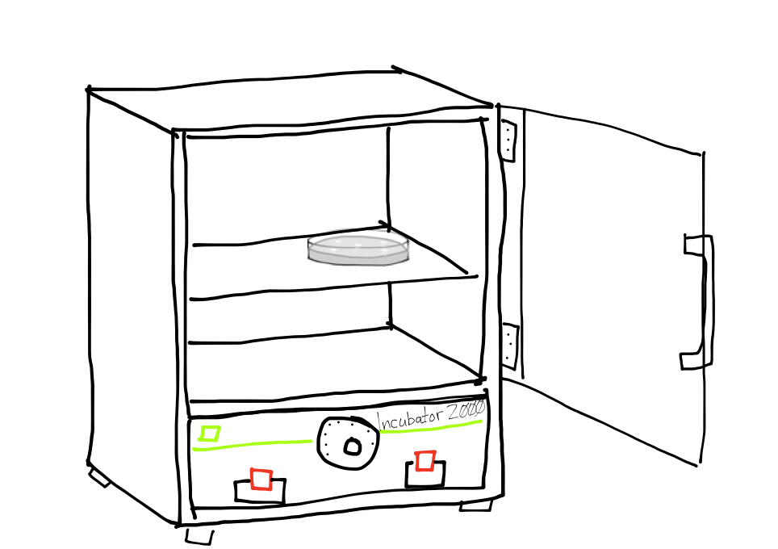
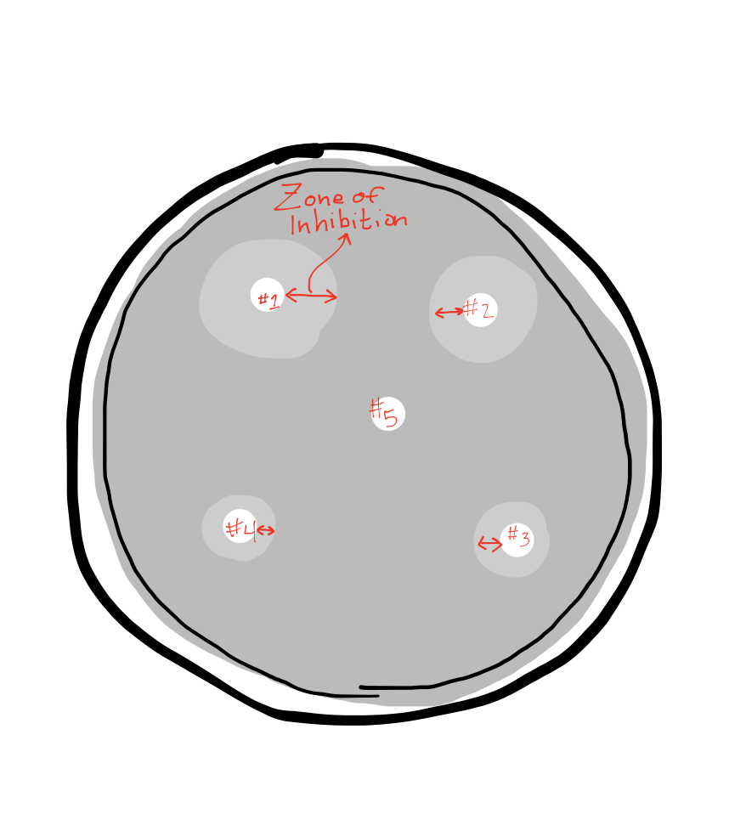
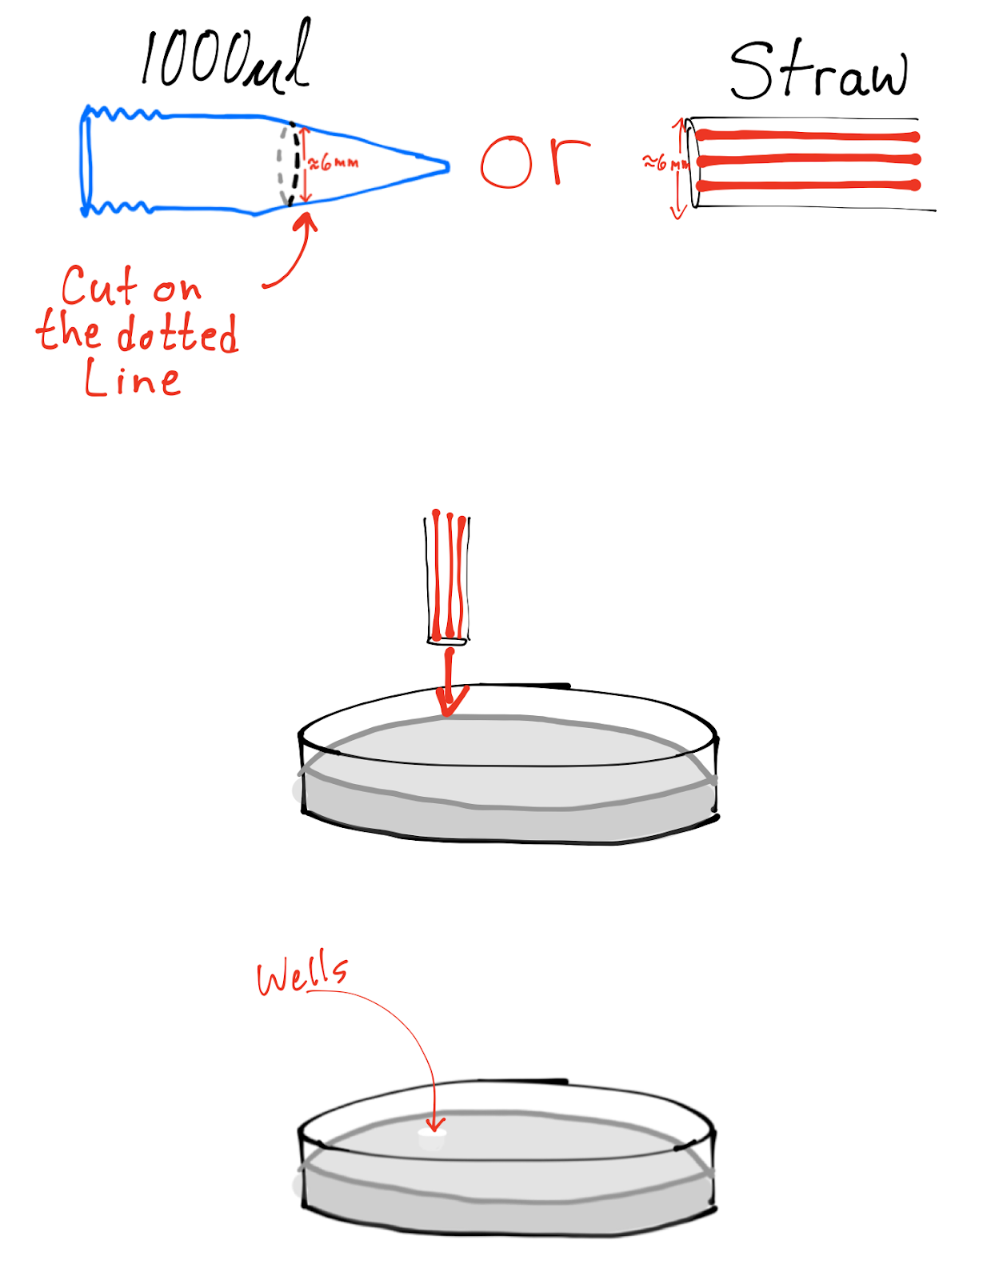
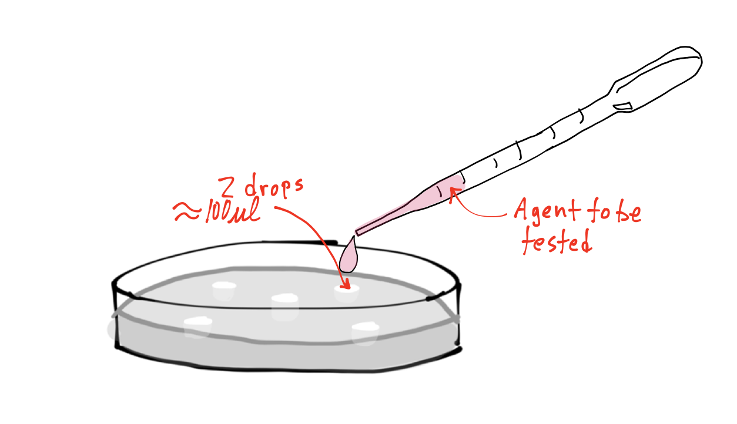
G
F
D
E

Post Lab Questions for Cytotoxicity Assay:

1. Graph the concentration of Au-NPs & IPAs (x-axis) to the width of the zone of inhibition (y-axis). Measure the zone from the edge of the well to the outermost inhibited border.

a. At what concentration did the Au-NPs work best? ______________________________

b. What was the minimum concentration at which some microbial growth was inhibited? _______________________________________

c. Explain citing specific data from the graph. Are Au-NPs better or worse at inhibiting microbial growth?
_________________________________________________________________________________________________
_________________________________________________________________________________________________
_________________________________________________________________________________________________
_________________________________________________________________________________________________

2. It has been proposed that Au-NPs work better at inhibiting microbial growth while exposed to light as opposed to being in the dark. The mechanism thought to cause this is that as the light interacts with the Au-NPs reactive oxygen species (ROS) are created.

a. Give an example of an ROS. Research; give a 2 ways ROS kill microbes. (Hint DNA)
_________________________________________________________________________________________________
_________________________________________________________________________________________________
_________________________________________________________________________________________________
_________________________________________________________________________________________________
_________________________________________________________________________________________________
_________________________________________________________________________________________________

3. What simple tweak to this assay could measure the effect that light has on Au-NPs anti-microbial properties?
____________________________________________________________________________________________________________________________________________________________________________________________________________________________________________________________________________________________________________________________________________________________________________________________________________________________________

4. Assuming light does enhance the effect of inhibiting microbial growth; how might factor into how you might use Au-NPs in a real world application?
____________________________________________________________________________________________________________________________________________________________________________________________________________________________________________________________________________________________________________________________________________________________________________________________________________________________________

